DESIGN AND IMPLEMENTATION OF AN AUTOMATIC LIQUID DOSING SYSTEM

KADRİ EMRE ORGUN

ÖMER YÜCE

AYBERK KILLI

HAYDAR BARIŞ ÖCAL

THE ADVISOR: SERKAN DOĞANAY

The primary aim of the project is to automatically release a specified amount of liquid from a syringe.

In this context, We bought parts of the project that was created last year.

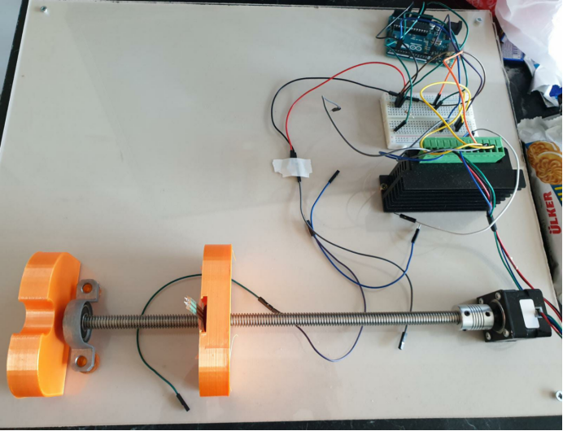

Then we started our work. In the first week, we talked about how to design.

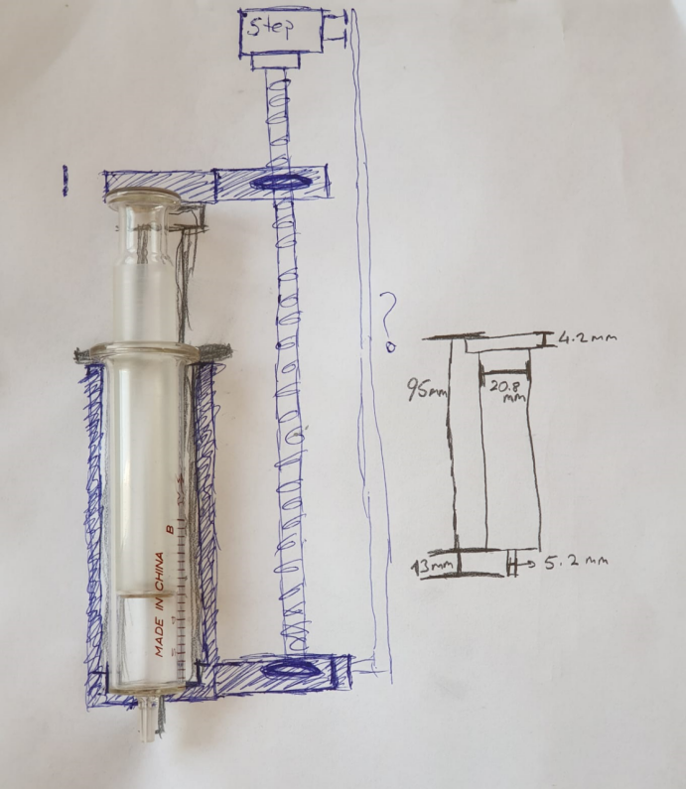

We drew our design in the SolidWorks program and printed it on a 3D printer.

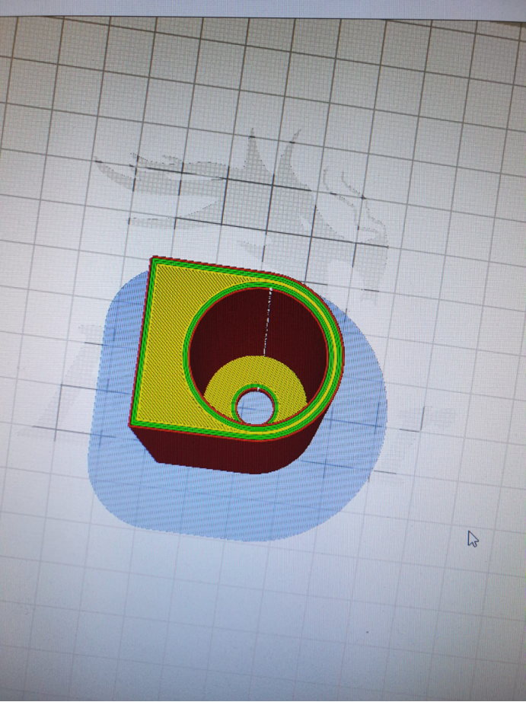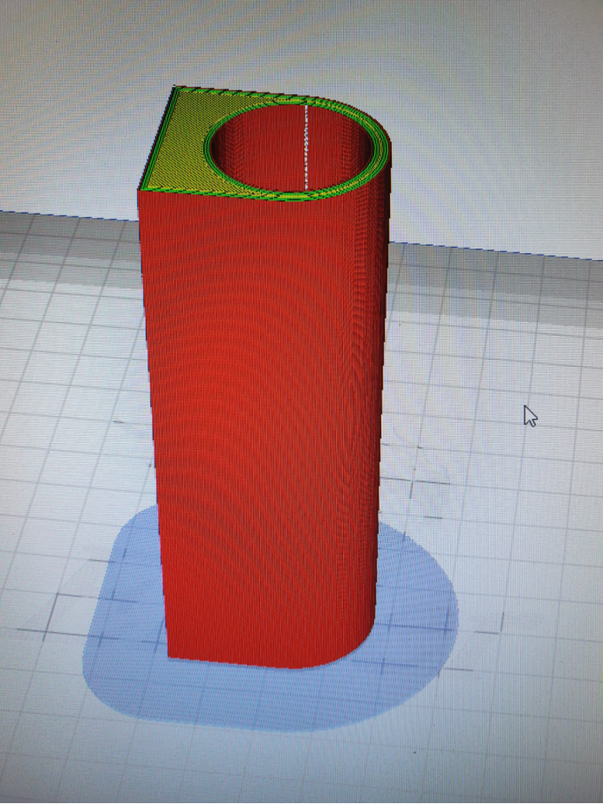

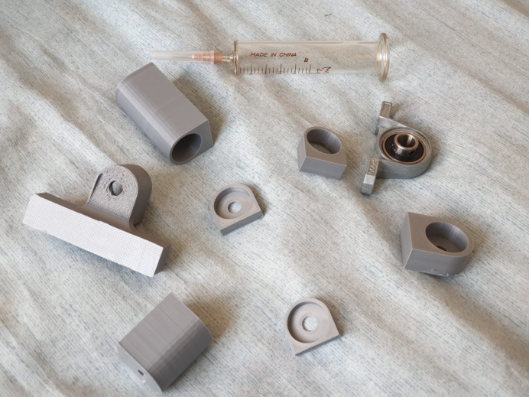

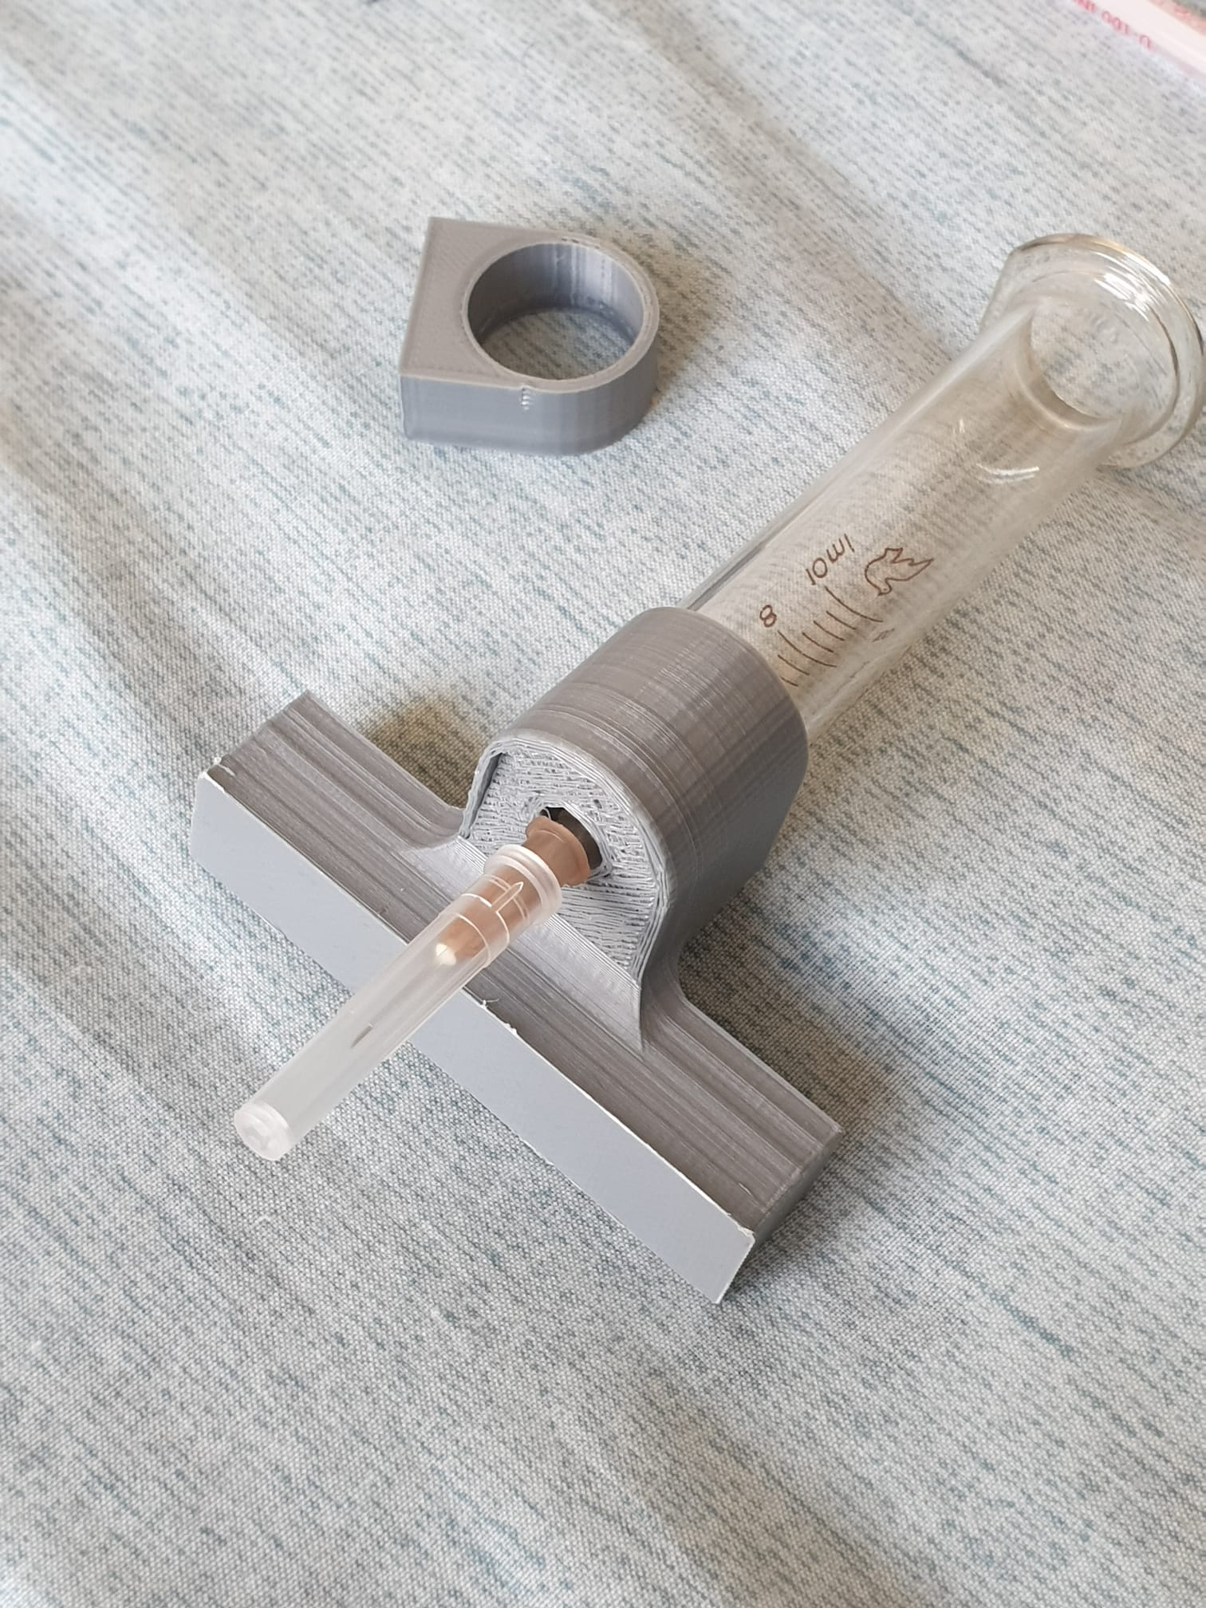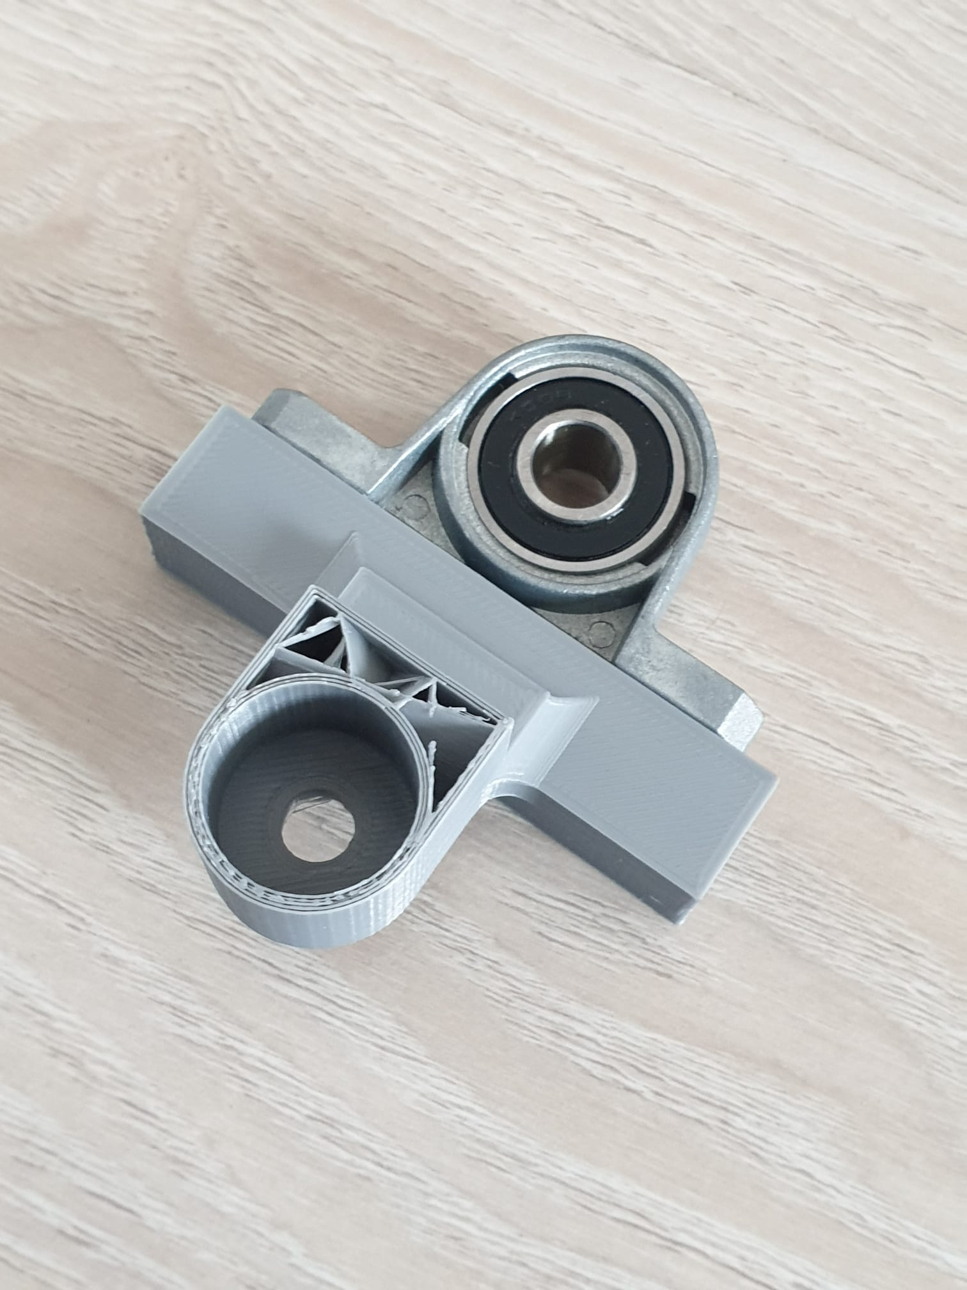

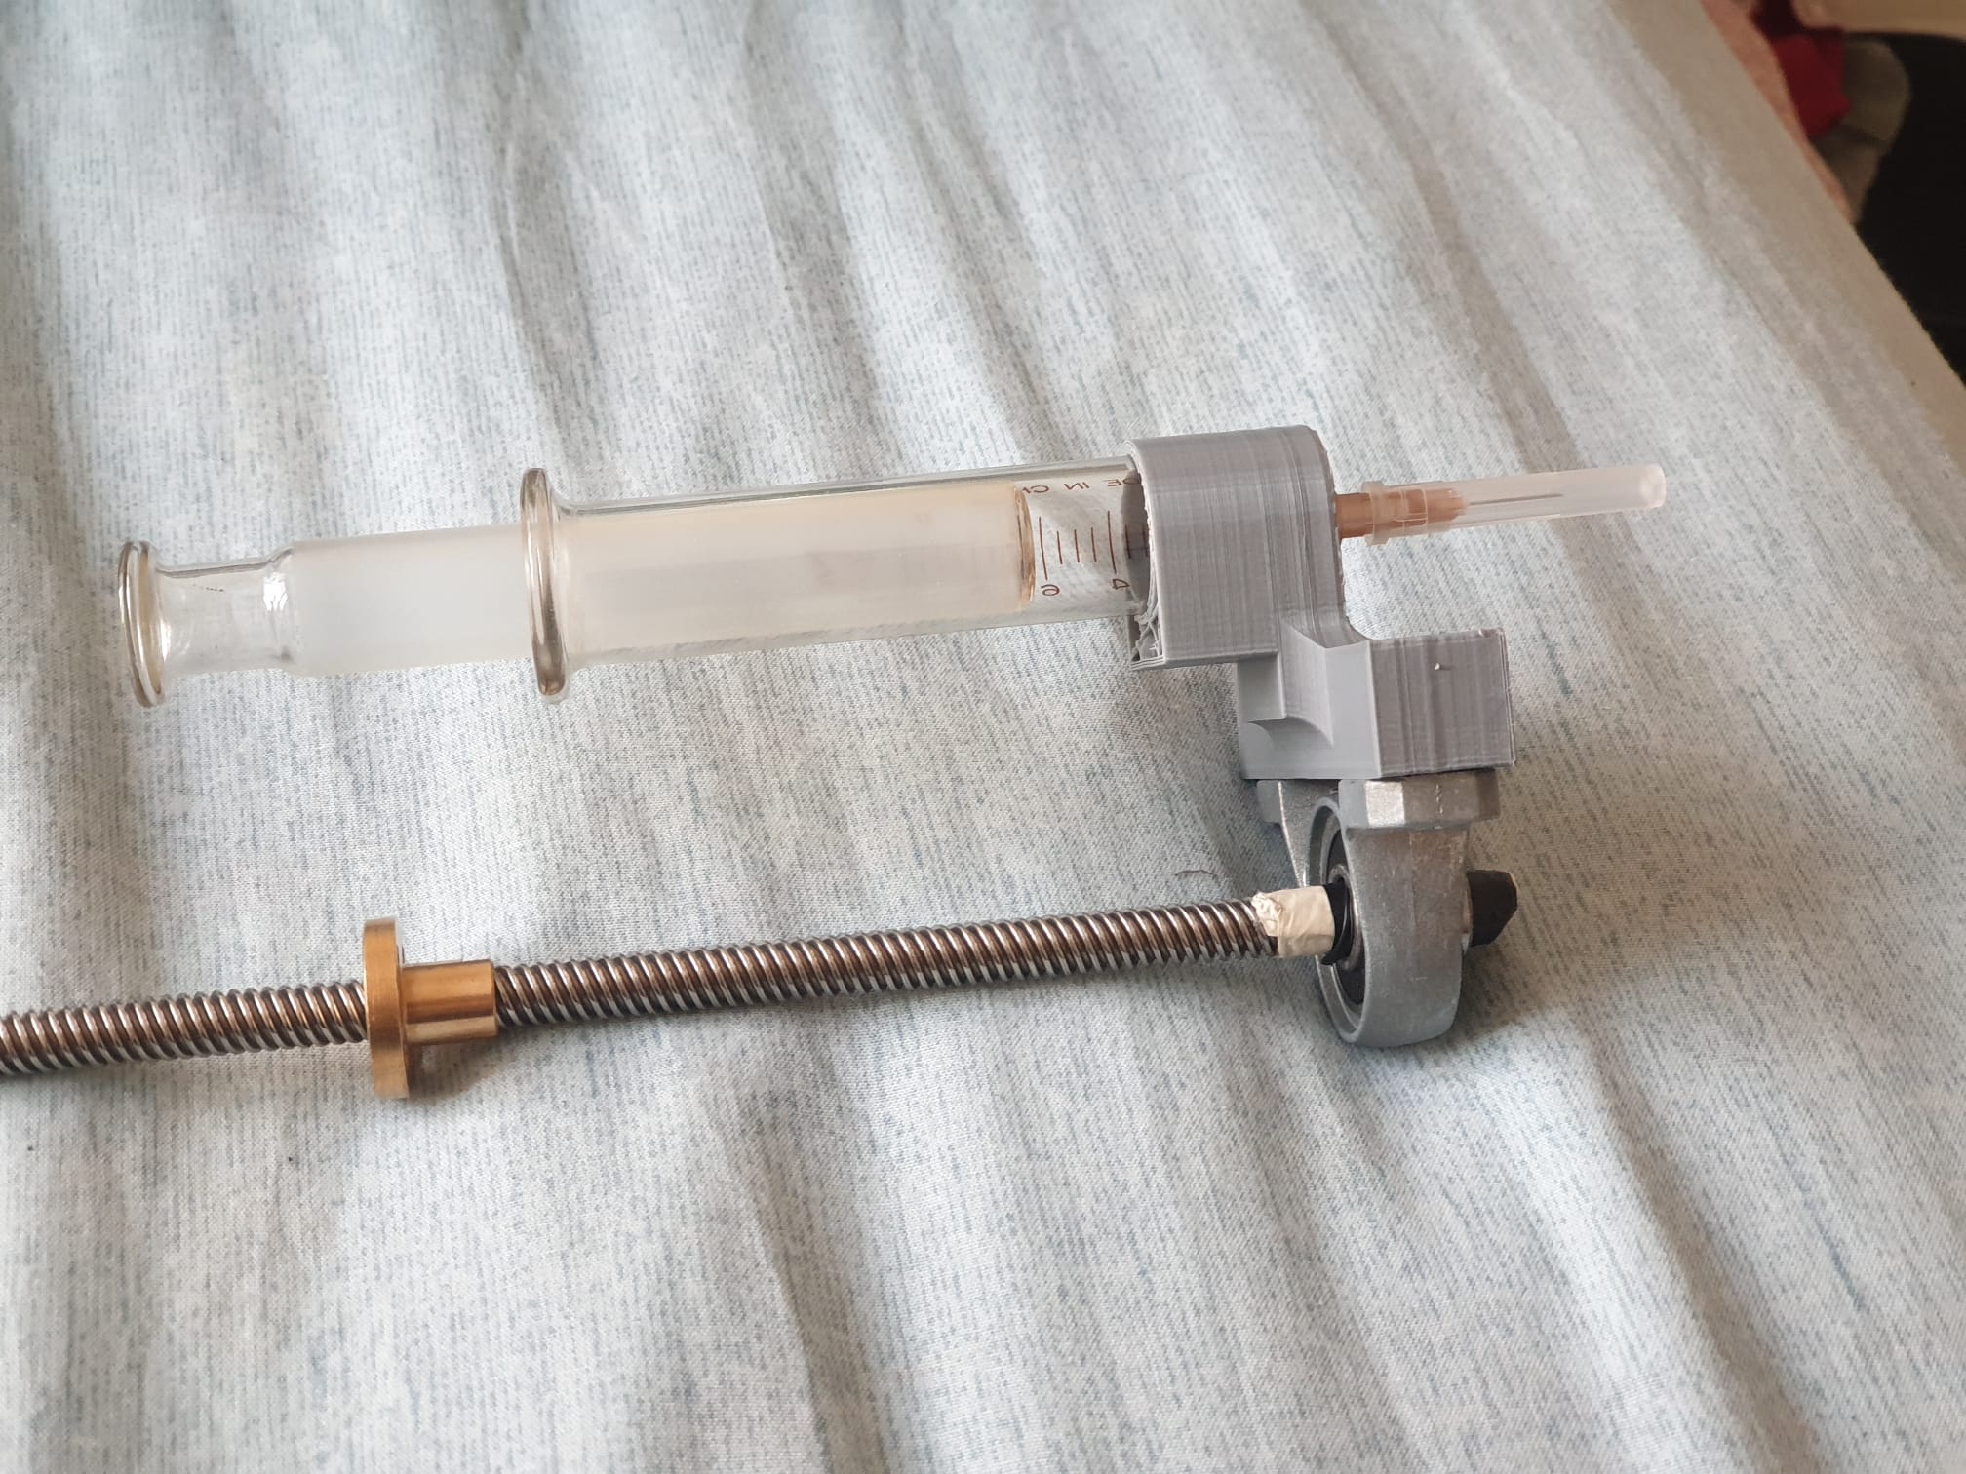

As a first step, we wrote code to fill and empty the entire syringe.

// Define stepper motor connections and steps per revolution:

#define dirPin 2

#define stepPin 5

#define stepsPerRevolution 6400 // çözünürlük 32'de, 10 voltta güç kaynağı, 0.5ampere sabitledik

void setup() {

// Declare pins as output:

pinMode(stepPin, OUTPUT);

pinMode(dirPin, OUTPUT);

}

void loop() {

// Set the spinning direction clockwise:

digitalWrite(dirPin, HIGH);

// Spin the stepper motor 0.5 revolution :

for (int i = 0; i < 0.5 \* stepsPerRevolution; i++) { // tur sayısını burdan hesaplıyoruz

// These four lines result in 1 step:

digitalWrite(stepPin, HIGH);

delayMicroseconds(500); // hız (arttıkça hızı azalıyor, en hızlı 9.)

digitalWrite(stepPin, LOW);

delayMicroseconds(500); // hız (arttıkça hızı azalıyor, en hızlı 9.)

}

delay(1000);

// Set the spinning direction counterclockwise: // saat tersine

digitalWrite(dirPin, LOW);

// Spin the stepper motor 0.5 revolutions fast:

for (int i = 0; i < 0.5 \* stepsPerRevolution; i++) { // tur sayısını burdan hesaplıyoruz

// These four lines result in 1 step:

digitalWrite(stepPin, HIGH);

delayMicroseconds(500); // hız (arttıkça hızı azalıyor, en hızlı 9.)

digitalWrite(stepPin, LOW);

delayMicroseconds(500); // hız (arttıkça hızı azalıyor, en hızlı 9.)

}

delay(1000);

}

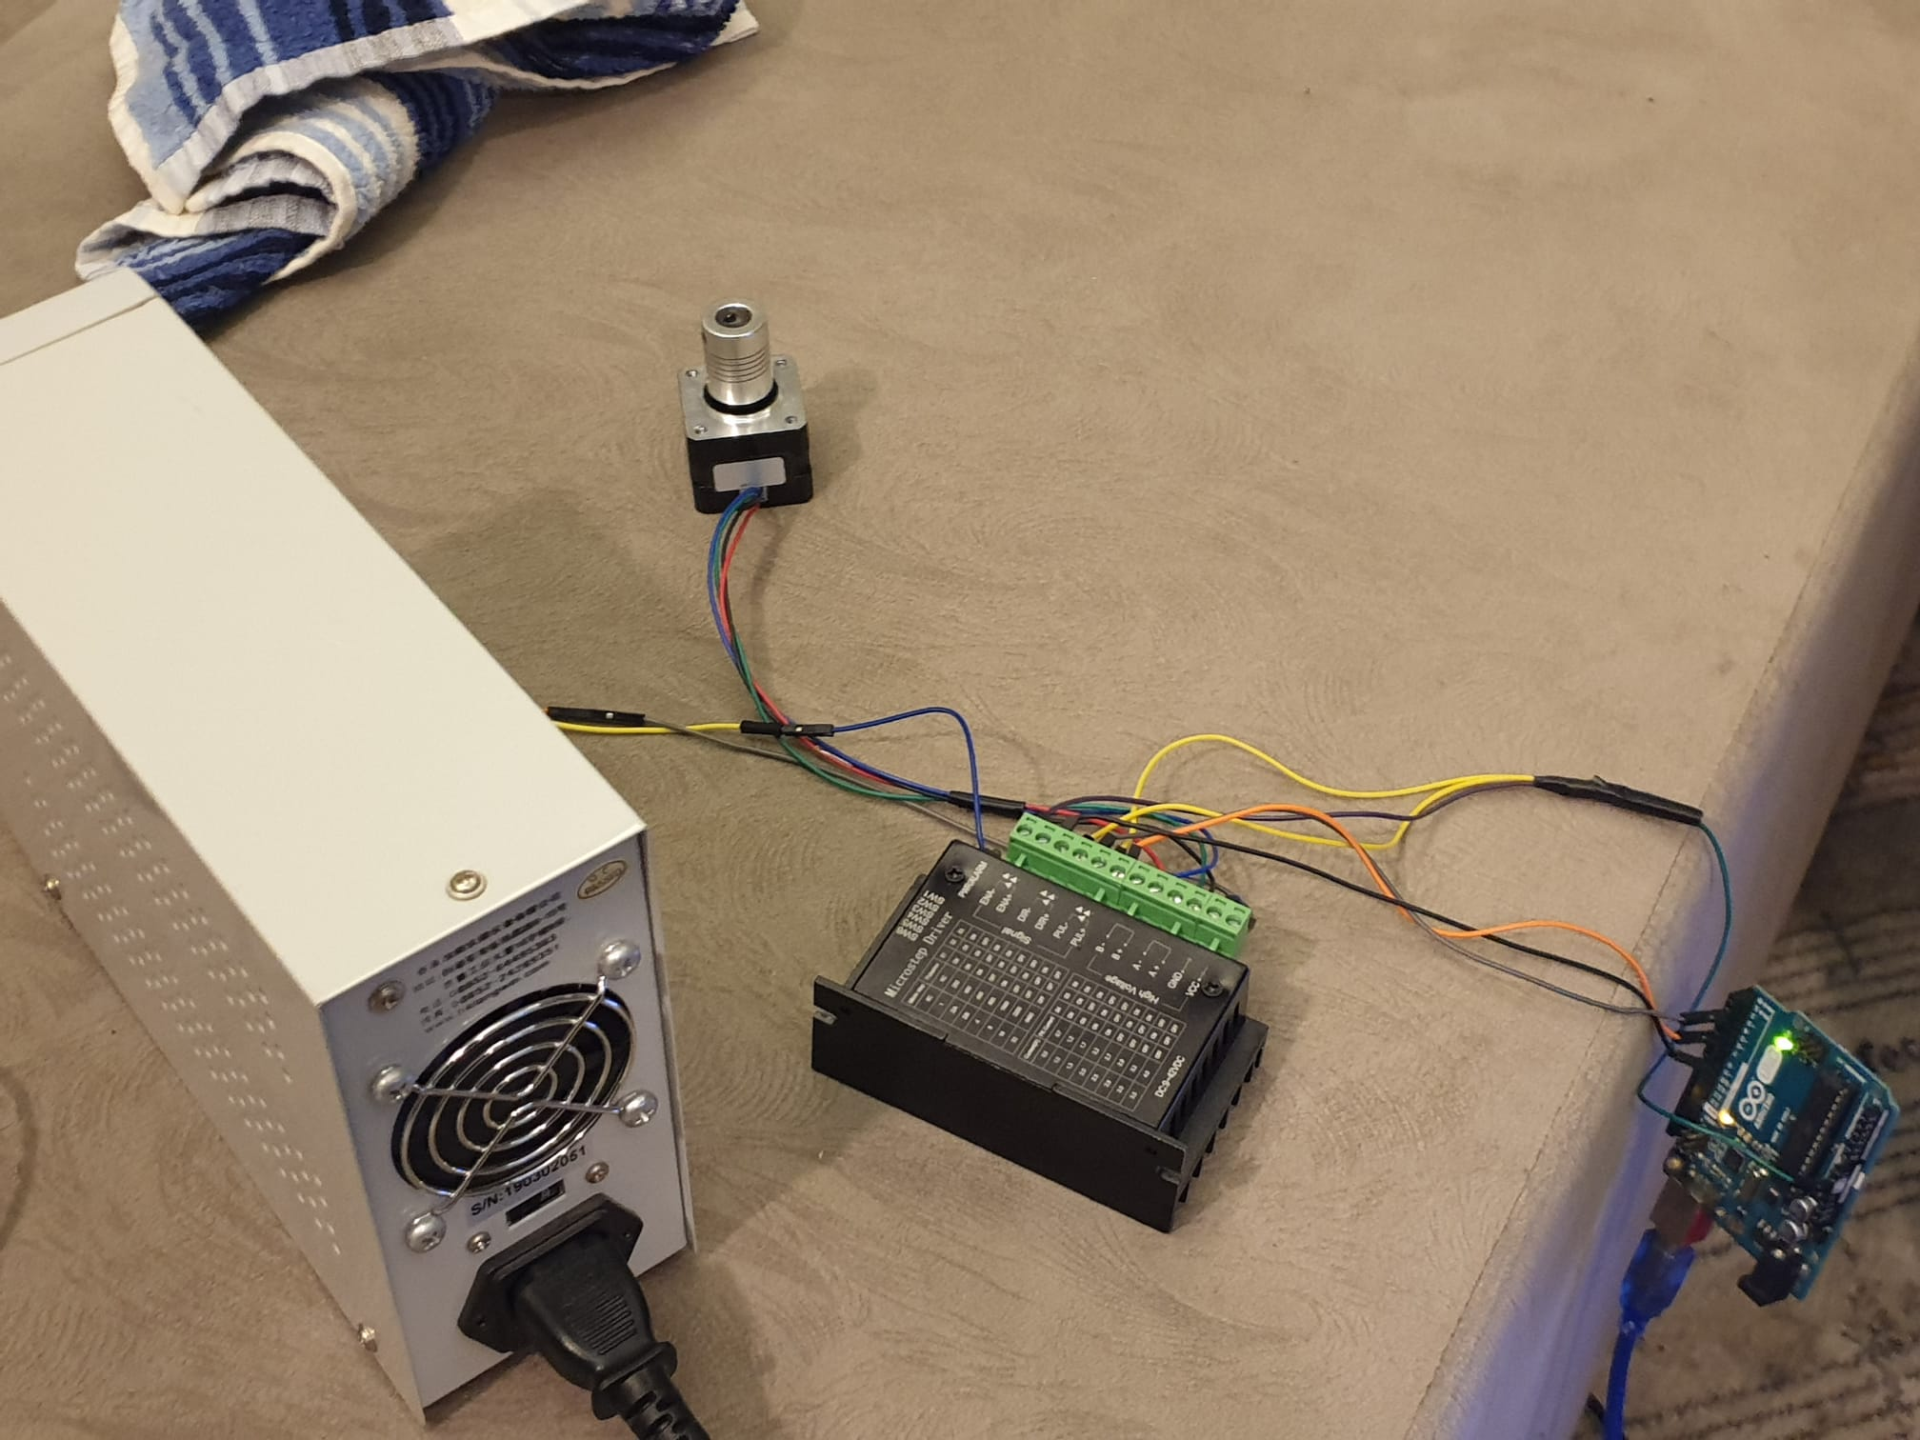

In the first week we used Nema 14 stepper motor, TB6600 motor driver and ardunio

In the 2nd week, the task distribution was made by Serkan teacher. Accordingly, the connection diagram of the nema17 bipolar stepper motor was searched for use in the project. We researched the syringe models and sensor types that we can use in the project.

Connection diagram of Nema 17 stepper motor is as in the figure.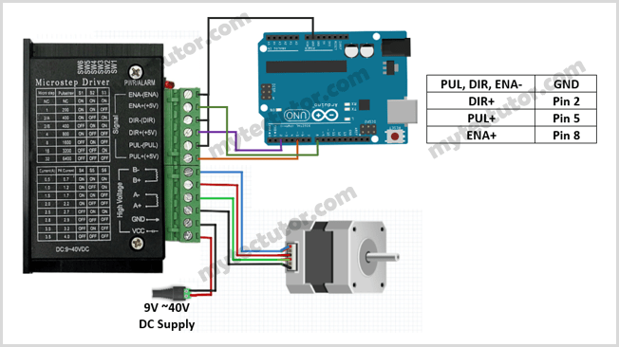

We thought to use 3 sensor for optimizing our system.

1) Ultrasonic Liquid Level Sensor

2) Round Force Sensitive Sensor

3) Linear Encoder or Laser Distance Sensor

1) Ultrasonic Liquid Level Sensor: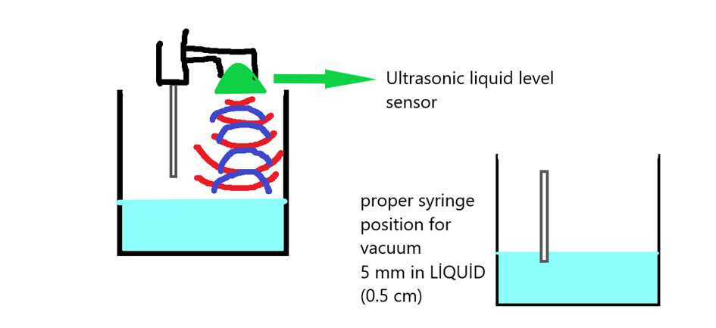

An ultrasonic liquid level sensor is an instrument for measuring the height of a liquid and converting it to an electrical signal. The liquid level signal output can then be utilised by other instrumentation to display, monitor, log or control the liquid level.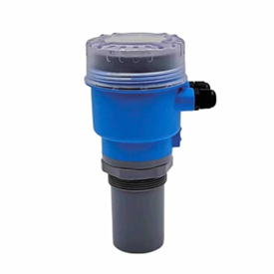

According to our research, it is sufficient for the pipette or syringe tip to be within 5 mm of the liquid for liquid dosing. We chose this sensor to monitor this distance, to measure the distance regularly and to ensure that the vacuum tip is always in the liquid.

2) Round Force Sensitive Sensor: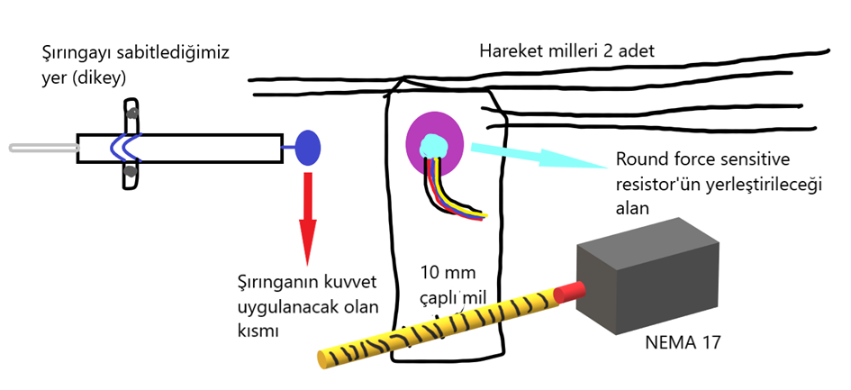

A force sensitive resistor is a material which changes its resistance when a force or pressure is applied.

We thought of using a linear encoder or laser distance sensor for position tracking of the system. However, we thought to use this sensor in order to avoid any errors that may occur in these sensors and because these sensors are insufficient to monitor the maximum and minimum limits of the syringe.

Our purpose in using this sensor is to cut the power to the motor when the power applied by the plate to the syringe exceeds a certain level.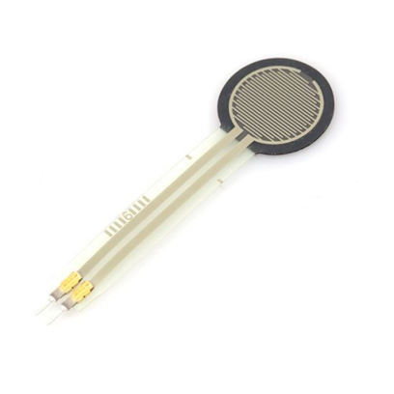

3) Linear Encoder or Laser Distance Sensor:

Linear encoder is a sensor or transducer that measures linear movement of an object. The device can move in different directions but always travels along one axis. It can detect speed, distance, direction, and displacement.

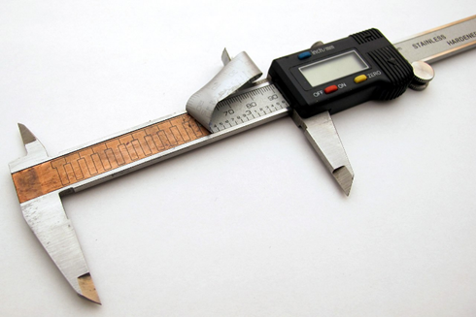

For Laser Distance Sensor, the distance measurement is based on the triangulation principle. The laser beam strikes the object as a small point. The receiver of the sensor detects the position of this point.

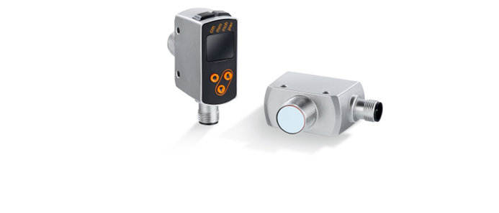

We thought of using one of these two sensors for linear position control in the system. We thought it would be more precise to use the linear encoder for positioning.

ARTICLE SOURCES

1. <https://www.researchgate.net/profile/Stefan-Bammesberger/publication/235945532_A_Calibration-Free_Disposable_Non-Contact_Reagent_Dosing_Cartridge_for_the_Sub-ul_Range/links/0deec5149bd9747d89000000/A-Calibration-Free-Disposable-Non-Contact-Reagent-Dosing-Cartridge-for-the-Sub-ul-Range.pdf>